Annex A

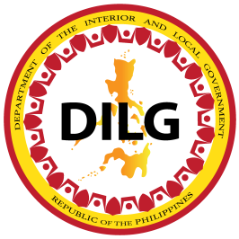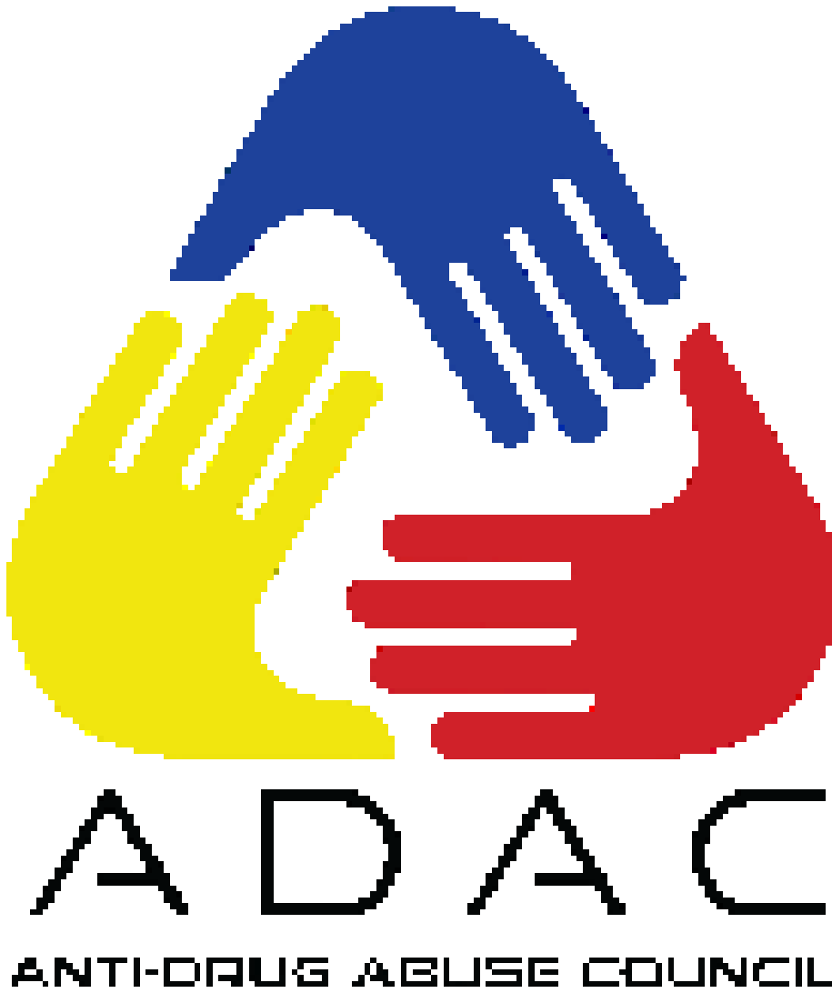

Republic of the Philippines
DEPARTMENT OF THE INTERIOR AND LOCAL GOVERNMENT
DILG-NAPOLCOM Center, EDSA corner Quezon Avenue, Quezon City
www.dilg.gov.ph

DILG PHILIPPINE ANTI-ILLEGAL DRUGS STRATEGY -
PROJECT MANAGEMENT OFFICE

anti-drug abuse council
performance audit
protocol

The Comprehensive Dangerous Drugs Act of 2002 highlighted the important participation of local government units (LGUs) in the implementation of anti-illegal drugs program, activities and projects. This is further strengthened by the President’s approval of the Philippine Anti-illegal Drugs Strategy (PADS) which is the government’s blueprint of strategies and programs in addressing the nation’s drug abuse problem using a whole-of-nation approach. The PADS is anchored on the sub-goal set by Chapter 18 of the Philippine Development Plan (PDP) 2017-2022 of ensuring security, public order and safety by suppressing the supply of illegal drugs while reducing consumer demand for dangerous drugs and other illicit substances.

As early as 1998, the Department of the Interior and Local Government has encouraged LGUs to organize their respective Anti-Drug Abuse Councils (ADACs). These multi-sectoral councils are tasked to formulate plans and implement local anti-drug abuse programs, projects and activities. Series of related policies reiterating the organization of local ADACs and enumerating their specific roles and responsibilities have likewise been issued. These include the Department and the Dangerous Drugs Board (DILG-DDB) Joint Memorandum Circular (JMC) No. 2018-01 which provides for the guidelines on the functionality and effectiveness of local ADACs.

This ADAC Performance Audit Protocol is necessary to guide all DILG Field Personnel involved in the gathering, submission, and verification of all required documents pursuant to existing legal mandate.

- RATIONALE

This Anti-Drug Abuse Council (ADAC) Performance Audit is a collaborative effort between national government agencies (NGAs), local government units (LGUs), and civil society organizations (CSOs). It employs a multi-level and participatory audit structure to ensure the integrity of the audit process and its results. This Performance Audit aims to achieve the following:
    - Assess the functionality and effectiveness of local ADACs based on existing issuances and policies;
    - Determine ADAC-initiated and / or -endorsed innovations and best practices at all levels;
    - Create a platform for evaluation and assessment;
    - Recognize the best, effective, and performing ADACs.

- COVERAGE
This policy shall cover all Provincial, City, and Municipal Anti-Drug Abuse Councils (ADACs) from the eighty-one (81) provinces, one hundred forty-six (146) cities, and one thousand four hundred eighty-eight (1,488) municipalities under the jurisdiction of seventeen (17) DILG Regional Offices.

To ensure the continuous improvement and performance of ADACs in the implementation, monitoring and evaluation of anti-illegal drug activities, the DILG-BLGS, through DILG Philippine Anti-Illegal Drug Strategy (PADS) - PMO will conduct a Performance Audit in the Provincial, City and Municipal ADACs to ascertain their functionality (i.e. high, moderate, and low).

III. DEFINITION OF TERMS

- Local Chief Executive - refers to Municipal Mayors, City Mayors, and Provincial Governors as Chairman of their respective Anti-Drug Abuse Councils (ADAC).
- LGU ADAC Focal Person – refers to persons appointed by Mayors based on Executive Order/Local Ordinance responsible for the data gathering and uploading.
- Best, performing, effective ADAC – refers to ADACs attained high functionality scores and passed on eligibility requirements.
- DILG ADAC Focal – refers to DILG Local Government Operations Officers (LGOOs) appointed by the Regional Directors responsible for all coordination regarding ADAC Programs at regional level.
- APT (ADAC Provincial Audit Team) – refers to a group convened at Provincial level responsible for auditing C/MADACs.
- ART (ADAC Regional Audit Team) – refers to a group convened at Regional level responsible for auditing the PADACs.
- RTA (Regional Technical Assistants) - refers to a group responsible for the creation of accounts for the Regional Managers, ADAC Regional Audit Teams, ADAC Provincial Audit Teams, and LGU ADAC focal persons.

- PERFORMANCE AUDIT MECHANISM

- PERFORMANCE AUDIT TEAMS
The following teams shall be assembled and convened by the responsible office to verify submitted document and conduct performance audit:

- ADAC Provincial Audit Team (APT)
The ADAC Provincial Audit Teams (APT) shall be assembled and convened by the DILG Provincial Office. The five (5)-member team shall be chaired by the DILG Provincial Director or his representative, and shall be composed of representatives from the provincial Philippine National Police (PNP), Philippine Drug Enforcement Agency (PDEA), and two (2) CSOs.

- ADAC Regional Audit Team (ART)
The ADAC Regional Audit Teams (ART) shall be assembled and convened by the DILG Regional Office. The five (5)-member team shall be chaired by the DILG Regional Director or his representative and shall be composed of representatives from the regional PNP, PDEA, and two (2) CSOs.

- ADAC National Audit Team (ANT)
The ADAC National Audit Team (ANT) shall be assembled and convened by the ADAC PMO The five (5)-member team shall be chaired by the DILG Secretary or his representative and shall be composed of representatives from the DDB, PNP, PDEA, and one (1) CSO.

- PERFORMANCE AUDIT TOOLS

Only the prescribed system and tools shall be used in the submission of Modes of Verification (MOVs) and documentation of results and observations during the audit process.
  - Data Gathering and Capture
- DC1 is a list of required documents to be prepared and submitted by the ADACs of component cities and municipalities to their respective City/ Municipal Local Government Operations Officer.
- DC2 is a list of required documents to be prepared and submitted by the Provincial ADACs to their respective Provincial Director.
  - Data Verification
- The Anti-Drug Abuse Council – Functionality Monitoring System (ADAC-FMS), developed by DILG, is adopted as the official monitoring tool for ADAC functionality and performance. The ADAC-FMS shall be used for the submission and verification of MOVs, allocation of functionality points, and generation of results and reports.
- To ensure immediate availability and accessibility of data, Provincial, City, and Municipal ADAC Focal Persons shall keep the Document Checklist and all attached MOVs submitted by the ADACs for the duration of the audit process.
- Regional and Provincial ADAC Focal Persons shall keep copies of all signed Score Sheets for record purposes.

- PERFORMANCE AUDIT PROCESS

The following process and procedure shall be followed in the conduct of the performance audit:
- Creation of Accounts
- DILG National shall create accounts for the Regional Technical Assistants.
- DILG Regional Technical Assistants shall create accounts for the Regional Managers, ADAC Regional Audit Teams, ADAC Provincial Audit Teams, and LGU ADAC focal persons.
b. Data Gathering and Capture
- Within the specified period, all LGU ADAC focal persons shall gather all required Modes of Verification (MOVs) as listed in the Document Checklist.
- Upon gathering all required MOVs, the LGU ADAC focal persons shall endorse all gathered MOVs to the Local Chief Executive for signature.
- Upon signing of all gathered MOVs, the Local Chief Executive shall endorse all of the signed MOVs back to the LGU ADAC focal persons to upload all gathered MOVs and answer the necessary data capture questions using the ADAC-Functionality Monitoring System (ADAC-FMS). To complete the data capture process, an Attestation (attached) to the authenticity of gathered MOVs shall be signed by ADAC Chairperson.
- After uploading MOVs on the ADAC-FMS, the original copy of all MOVs shall be submitted to their respective audit teams for assessment process. In the case of City and Municipality ADAC, submit to APT, in the case of HUCs, ICC and Province submit to the ART.
- To ensure availability and accessibility of data, DILG ADAC Focal Persons shall keep a copy of Document Checklist and all attached MOVs submitted by the ADACs for the duration of the audit process.
c. Audit Phase
- Upon the submission of all MOVs to their respective audit teams, DILG shall convene the APT/ART to conduct the audit process.
- The ART/APT shall use the ADAC-FMS in encoding all the data from the original MOVs submitted by the LGU ADAC Focal Persons to conduct the audit.
- After the conduct of audit, the APT shall generate the report through the Functionality Monitoring System.
- Upon generating the downloaded reports from the Functionality Monitoring System, the APT shall sign the downloaded reports
- Upon signing of downloaded reports, the APT shall reupload the signed generated reports to the FMS and shall be endorsed to the ART.
d. Submission of Audit Result
- After the ART has received all of the generated reports from the FMS, the ART shall consolidate all of the generated reports of result.
- Upon consolidating all of the reports of results, the ART shall endorse all the consolidated reports to the ANT.
- The ANT shall consolidate all submitted regional reports in preparation for the calibration and finalization of audit results.
- All reports submitted by each audit team shall be in hard copy and soft copy.
- All Regional reports submitted to ANT, shall be declared as valid and final.
e. Audit Results Calibration and Finalization
- The BLGS, through the DILG PADS-PMO, shall convene the ANT to conduct the calibration and finalization of Audit Results.
- The ANT shall consolidate, calibrate, deliberate, and finalize the audit results.
- Once the results are finalized, the DILG PADS-PMO shall generate the National Reporting Form (NRF) using the ADAC-FMS.
- Once the ANT generated the national reports, it shall be presented to the SILG and shall be declared as valid and final.

- PERFORMANCE AUDIT CRITERIA
The following main and sub performance indicators for the CADAC/MADAC will be measured based on the provisions set forth in DILG-DDB JMC No. 2018-01:
  - Creation / Reorganization of ADAC (10 points)
    - Creation / Reorganization of CADAC / MADAC (5 points)
    - Composition of members complaint to DILG-DDB JMC No. 2018-01
(5 points)
  - Allocation of substantial amount as indicated in the ADAC Plan (15 points)
    - Allocation of substantial amounts for the implementation of anti-illegal drug activities as indicated in their respective Approved POPS Plan, Annual Budget or Annual Investment Plan (AIP). For AIP, the front page, table of contents, actual part for anti-illegal drugs, and the last page with signature should all be uploaded.
  - Implementation of ADAC Plans and Programs (40 points)
    - Financial Accomplishment (10 points)
    - Physical Accomplishment (10 points)
    - Percentage of Drug-Cleared Barangays of Component LGUs (15 points)
    - Timeliness of Implementation (5 points)
  - Support to ADACs in Component LGUs (20 points)
    - Formulation of Community Support, Aftercare and Rehabilitation (CSAR) Plan (10 points)
    - Financial Support to component ADACs (5 points)
    - Technical support to component ADACs (5 points)
  - Conduct of Quarterly Meetings (10 points)
    - Local ADAC meetings regularly conducted.
  - Innovation/s (5 points)
Any of the following:
    - Any LGU-initiated activity, facility, or program that is outside of the prescribed functions and responsibilities of said LGU;
    - any local ADAC Member Agency-initiated activity, facility, or program that is outside of the prescribed functions and responsibilities of said member agency duly endorsed by the local ADAC through a resolution; or,
    - any civil society organization (CSO)-initiated activity, facility, or program conducted in cooperation with the LGU through a Memorandum of Agreement/Understanding (MOA/U) and duly endorsed by the local ADAC through a resolution.
The following main and sub performance indicators for the PADAC will be measured based on the provisions set forth in DILG-DDB JMC No. 2018-01:
- Creation / Reorganization of ADAC (10 points)
i. Creation / Reorganization of PADAC (5 points)
ii. Composition of members compliant to DILG-DDB JMC No. 2018-01 (5 points)
- Allocation of substantial amount as indicated in the ADAC Plan (15 points)
i. Allocation of substantial amounts for the implementation of anti-illegal drug activities as indicated in their respective Approved POPS Plan, Annual Budget or Annual Investment Plan (AIP). For AIP, the front page, table of contents, actual part for anti-illegal drugs, and the last page with signature should all be uploaded.
- Implementation of ADAC Plans and Programs (50 points)
i. Financial Accomplishment (15 points)
ii. Physical Accomplishment (15 points)
iii. Percentage of Drug-Cleared Barangays of Component LGUs (15 points)
iv. Timeliness of Implementation (3 points)
v. Establishment of Special Drug Education Centers (2 points)
- Support to ADACs in Component LGUs (10 points)
i. Functionality and effectiveness of component ADACs (5 points)
ii. Financial and/or technical support to component ADACs (5 points)
- Conduct of Quarterly Meetings (10 points)
i. PADAC conducted quarterly meetings
- Innovation/s (5 points)
Any of the following:
i. Any LGU-initiated activity, facility, or program that is outside of the prescribed functions and responsibilities of said LGU;
ii. any local ADAC Member Agency-initiated activity, facility, or program that is outside of the prescribed functions and responsibilities of said member agency duly endorsed by the local ADAC through a resolution; or,
iii. any civil society organization (CSO)-initiated activity, facility, or program conducted in cooperation with the LGU through a Memorandum of Agreement/Understanding (MOA/U) and duly endorsed by the local ADAC through a resolution.

- ADJECTIVAL RATING OF FUNCTIONALITY
The adjectival rating of ADAC performance and functionality are as follows:
Audit Score | Adjectival Rating | Classification
85 – 100 | High Functional | Ideal
51 – 84 | Moderate Functional | Progressive
50 below | Low Functional | Basic

- Only ideal ADACs, or those with high functionality, may be eligible for the national recognition which may be in the form of certificates, plaques, and/or cash incentives, subject to the availability of funds.
- Basic ADACs, or those with low functionality, shall be recommended for the appropriate intervention and/or legal action. Non-compliant ADACs, or those with zero (0) points due to non-submission of MOVs, shall be recommended for appropriate legal action.
- INDICATIVE TIMELINE

Audit Phase | Audit Year | Schedule
Phase 1: Data Gathering and Uploading Phase | 2019 | Component Cities/Municipalities  May 3 – 14
Provinces/HUCs/ICCs
May 31 – June 11
 | 2020 | Component Cities/Municipalities  June 28 – July 9
Provinces/HUCs/ICCs
July 26 – August 6
Phase 2: ADAC Audit Phase | 2019 | Component Cities/Municipalities  May 17 – 28
Provinces/HUCs/ICCs
June 14 – 25
 | 2020 | Component Cities/Municipalities  July 12 – 23
Provinces/HUCs/ICCs
August 9 – 20
Phase 3: Audit Results Calibration and Finalization | 2019 | June 28 – July 9
 | 2020 | August 23 – September 3
Phase 4: Presentation of Audit Results to SILG | 2019 & 2020 | September

